**Human Growth**

**and**

**Development**

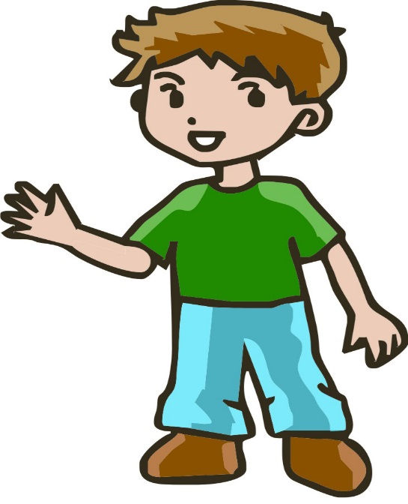

**5th Grade Boys**

**Student/ Parent Packet**

**Central Bucks School District**

**Overview of the Male Reproductive System**

Understanding the reproductive system is as important as understanding any other organ system of the body. Encourage students to learn this system and understand they function of each part. By becoming familiar with the male anatomy, boys can better comprehend the changes in their bodies as they grow. Require that they learn the correct terminology as well. Review pronunciation.

Begin by explaining that the main purpose of the male reproductive system is to produce sperm-the male reproductive cells. During puberty, testosterone enables the testicles to start producing mature sperm for the first time. (When a sperm cell reaches an egg of a woman and fertilization takes place, the woman becomes pregnant with a baby.) Sperm is combined with other fluid in the vas deferens to make the seminal fluid, which is called semen.

To explain how semen leaves the body (through ejaculation), you may want to trace the path of the sperm from the testicles, through the vas deferens (sperm duct), seminal vesicles, prostate gland, and the urethra. Define erection and ejaculation. Be sure to explain that urine also leaves the body through the urethra, but never at the same time as semen.

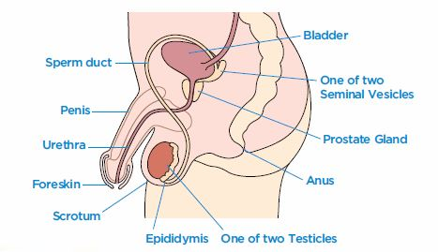

**Epididymis**: Tube at the back of each testicle that carries sperm to the vas deferens (sperm duct)

**Foreskin**: This fold of skin covers the end of the penis. Not all boys have a foreskin because some cultures, it is removed (an operation called circumcision) when a baby boy is only a few days or weeks old. Uncircumcised boys and men pull the foreskin back and wash under it as part of daily hygiene.

**Penis**: Male sex organ; also used to urinate.

**Prostate Gland**: Gland next to the bottom of the bladder; it forms a fluid that combines with sperm and a fluid from the seminal vesicles to make sperm.

**Scrotum**: Sac of skin that holds the testicles, just underneath the penis.

**Semen**: Male reproductive cells.

**Seminal vesicles**: Two glands on either side of the bladder that secrete seminal fluid.

**Sperm**: Male reproductive cells.

**Testicles**: Also called the testes; two oval-shaped organs that are contained in the scrotum. They produce the male hormone testosterone and sperm.

**Urethra**: Tue that carries urine and semen out of the body, but not at the same time.

**Vas Deferens**: Tubes in which sperm is combined with other fluids from the prostate gland and seminal vesicles to make sperm.

**Physical Changes at Puberty for Boys**

The male stages of development are typically described by the five Tanner stages of genital and pubic hair growth, along with other signs of male maturation: the deepening of the voice, the growth spurt, muscle development, and the growth of facial and body hair. It is important to emphasize that each boy’s progression through the stages will be slightly different according to his own body’s timetable, and boys usually move through the stages of puberty one or two years later than girls.

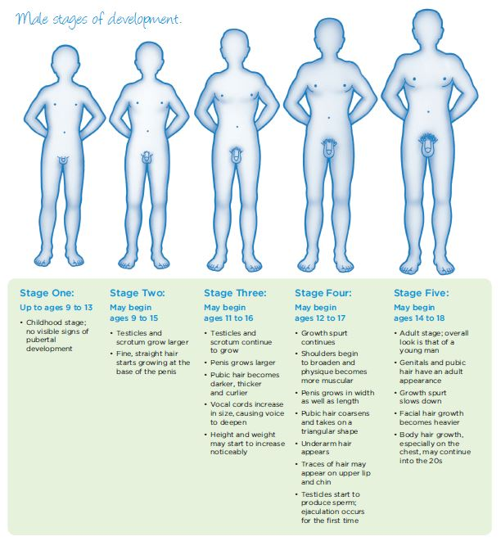

**UNIT II**

**Vocabulary Quiz- Male Puberty**

Match the words at the top with their descriptions below.

|  |  |  |  |
| --- | --- | --- | --- |
| A. | Puberty | H. | Epididymis |
| B. | Sperm cells | I. | Ejaculation |
| C. | Erection | J. | Genitals |
| D. | Testosterone | ·K. | Semen |
| E. | Scrotum | L. | Testicles |
| F.  G. | Nocturnal emission  Hypothalamus | M.  N. | Prostate gland  Penis |

1. _____ Ejaculating semen while asleep or almost asleep. It is also called a "wet dream."
2. ______ The principal external male reproductive organ.
3. _____ The external organs of the reproductive system.
4. ______ The period during which boys and girls experience the physical changes of growing up.
5. ______ A storage chamber, attached to each testicle, where sperm cells are nourished and mature.
6. ______ The spurting out of semen from the penis.
7. ______ A gland that surrounds the male urethra. It contributes a milky fluid that makes up the largest part of the semen.
8. _____ The tiny cells in a male, shaped like tadpoles that contain half the genetic material necessary to create a baby.
9. _____ The main male hormone which must be released in order for puberty to begin in boys.
10. _____ The sticky white fluid that helps transport sperm through the urethra and out the tip of the penis during ejaculation.
11. _____ The area of the brain in both boys and girls that is responsible for sending the message to the pituitary gland to start production of the hormones necessary for puberty to begin.
12. _____ The sac of loose skin that hangs under a male’s penis and contains the testicles.
13. _____ The enlarging and hardening of the penis.
14. _____ Two oval-shaped glands contained in the scrotum that make sperm.